**INTRODUCTION**

Ensuring the safety of aircraft operations, particularly during critical phases such as takeoff and landing, is paramount in the aviation industry. Central to this safety is the effectiveness of runway lighting systems, which provide crucial guidance to pilots in varying environmental conditions. Traditional systems face challenges in complexity, cost, and energy consumption, especially in adverse weather. Additionally, delayed response times during emergencies pose risks to both aircraft and personnel. To propel aviation safety into the future, a pioneering solution is proposed, harnessing Arduino-based control and Raspberry Pi technology to create a highly efficient, adaptable, and cost-effective runway lighting system. At its core, this system comprises a sophisticated network of sensors, Arduino microcontrollers, and communication modules, enabling dynamic control of various runway lights. Real-time data from sensors, such as proximity and weather sensors, empower the system to adjust lighting intensity and patterns dynamically, ensuring optimal visibility for pilots and ground personnel. What set’s this system apart is its rapid activation capabilities, ensuring immediate runway guidance during critical situations. By swiftly responding to aircraft movements, ambient light levels, and weather conditions, it significantly reduces the risk of accidents due to delayed responses, enhancing overall safety. Furthermore, the adaptability of Arduino and Raspberry Pi architecture enables integration of additional features, such as remote monitoring and control via wireless communication protocols like Wi-Fi or Bluetooth, enhancing operational efficiency and future-proofing the system against evolving safety requirements. The Arduino Integrated Development Environment (IDE) serves as a crucial tool in developing and programming the Arduino microcontrollers, providing an intuitive platform for code creation, compilation, and upload. Leveraging the intelligence and flexibility of Arduino microcontrollers and Raspberry Pi modules, this innovative runway lighting system represents a paradigm shift in aviation safety, meeting the dynamic demands of modern airports and airfields while ensuring safer and more efficient aircraft operations for years to come.

**Present Architecture:**

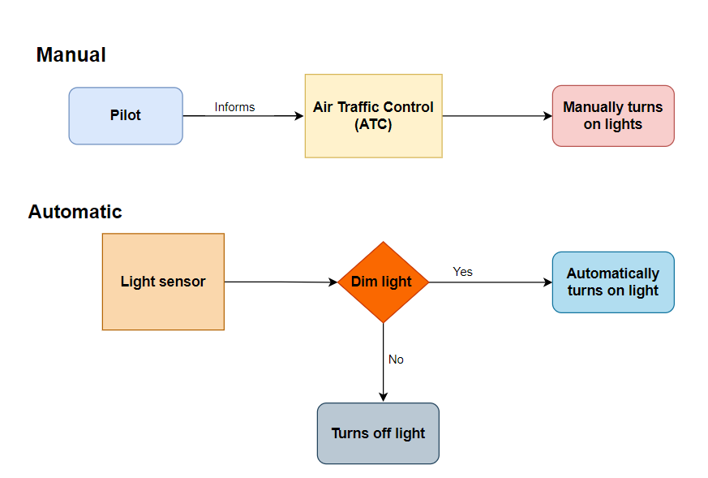

**Fig(a) Present architecture for manual and Automatic for runway lighting system**

Traditional manual architecture within runway lighting systems involves pilots communicating their imminent arrival or departure intentions to airport traffic control via radio or other designated communication channels. Upon reception of this critical information, control personnel then manually activate the requisite runway lights utilizing a dedicated control panel or an automated interface. This meticulous process ensures the timely and precise illumination of the runway, facilitating optimal guidance for pilots during pivotal phases of aircraft operations such as take-off, landing, and taxiing. Conversely, the automated architecture of runway lighting systems integrates advanced light sensing technology to govern illumination in a dynamic and responsive manner. Embedded light sensors are strategically positioned across the airfield, calibrated to detect fluctuations in ambient light levels. Upon detection of dimming conditions below predetermined thresholds, these sensors autonomously trigger the activation of runway lights, effectively ensuring requisite visibility for aircraft during essential manoeuvres. In instances where ambient light suffices, the system remains dormant, conserving energy and minimizing undue illumination. This automated framework is often synergistically coupled with sophisticated weather monitoring apparatus, enabling real-time adjustments to lighting intensity based on prevailing atmospheric conditions such as fog, rain, or snow. Such integration heightens operational safety and efficiency by furnishing tailored illumination solutions tailored to diverse environmental exigencies.

**Proposed Architecture:**

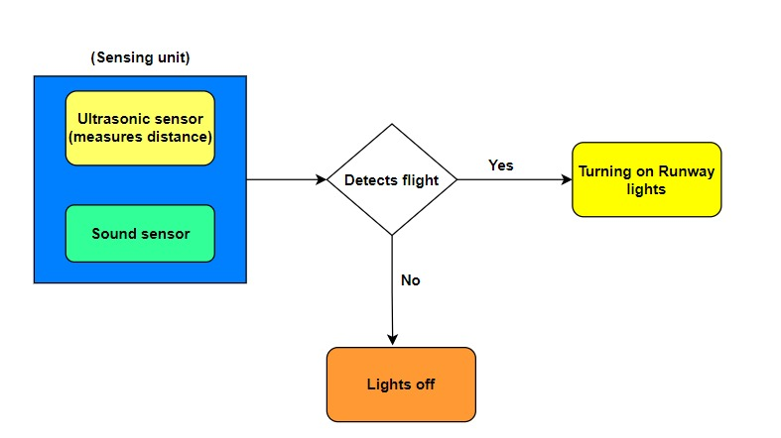

**Fig(b) Proposed architecture for runway lighting system**

In the proposed architecture, aircraft detection relies on two sensors: an ultrasonic sensor and a sound sensor. When either sensor detects the presence of a flight, the runway lights are activated; otherwise, they remain off. Ultrasonic sensors operate by emitting sound waves and measuring their return time, effectively gauging distances to objects. In this setup, ultrasonic sensors detect aircraft presence by measuring the waves bouncing off the aircraft. Sound sensors, on the other hand, directly pick up sound waves, including those generated by aircraft engines or other operational activities like landing gear deployment. By capturing distinct auditory signatures associated with aircraft operations, sound sensors significantly bolster the system's reliability in detecting aircraft on the runway. Combining both ultrasonic and sound sensors adds redundancy and resilience, minimizing the chances of false alarms or missed detections inherent in single-sensor setups. This dual-sensor strategy ensures prompt activation of runway lights upon aircraft detection, thereby elevating safety and visibility during crucial landing phases.

**IMPLEMENTATION**

The implementation process for the proposed aircraft detection and runway lighting system involves meticulous steps to ensure reliability and functionality. Firstly, connect the ultrasonic sensor to the breadboard, ensuring secure connections by aligning its pins with the appropriate rows on the board. Subsequently, establish electrical connections between the sensor's pins and the input/output pins of an Arduino UNO microcontroller using jumper wires. Concurrently, integrate an LED bulb into the circuit to serve as an indicator of flight detection, connecting it to the output pins of the microcontroller.

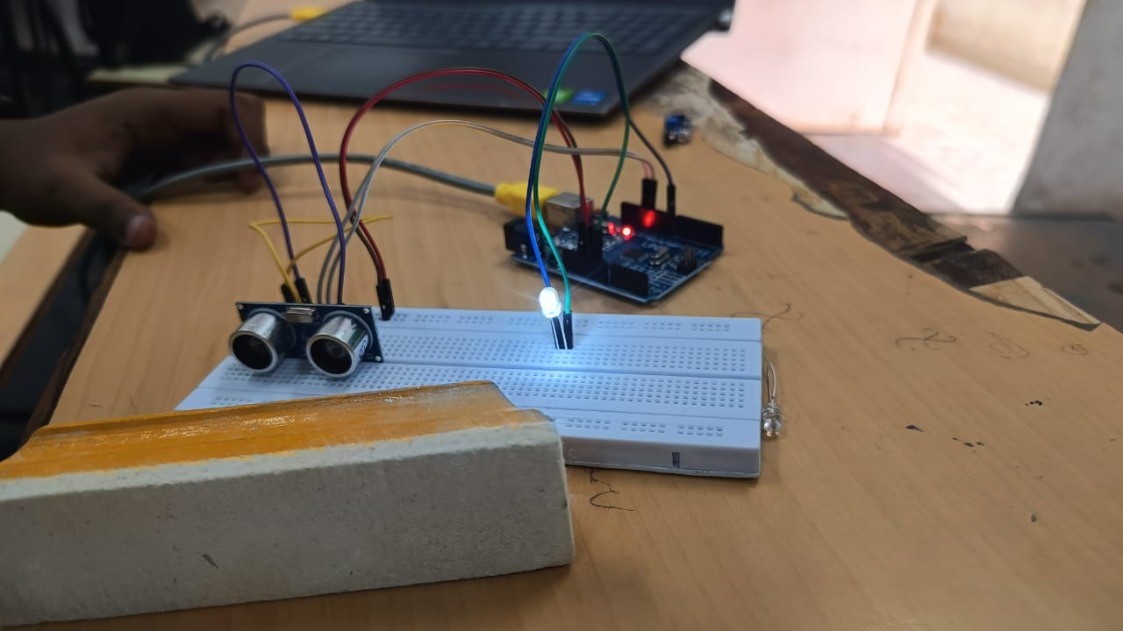

**Fig(c) Glowing a single LED using Ultrasonic Sensor**

Program the Arduino to interpret data received from the ultrasonic sensor, activating the LED bulb to signify the presence or proximity of an aircraft based on sensor readings. This programming facilitates real-time visual feedback, enhancing situational awareness for airport personnel. Additionally, ensure redundancy and reliability by employing serial connections for the LED bulbs, safeguarding against disruptions in lighting circuit operation due to individual bulb failures. Serially connected LED lights offer notable advantages for runway lighting systems, including energy efficiency, durability, and cost-effectiveness, aligning with modern airport infrastructure standards.

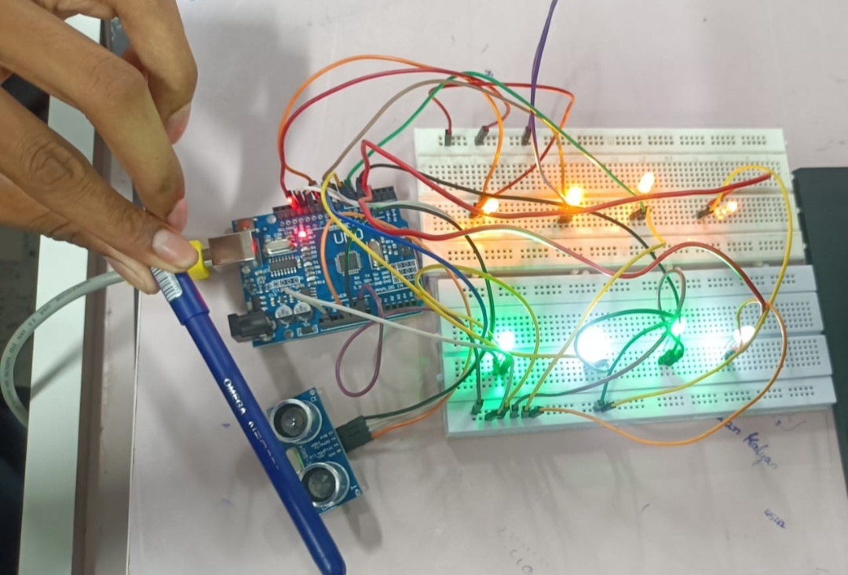

**Fig(d) Glowing a group of sequential LED’s using Ultrasonic Sensor**

Further augment the system's capabilities by integrating a sound sensor into the circuit, alongside another LED indicator, to enable sound-triggered responses. Establish electrical connections between these components and the Arduino board using male-to-male jumper wires, ensuring robust data transmission and control. Program the Arduino to detect sound levels captured by the sensor, regulating the illumination of the second LED accordingly. This comprehensive approach enhances the system's responsiveness and adaptability, contributing to enhanced safety and operational efficiency in airport environments.

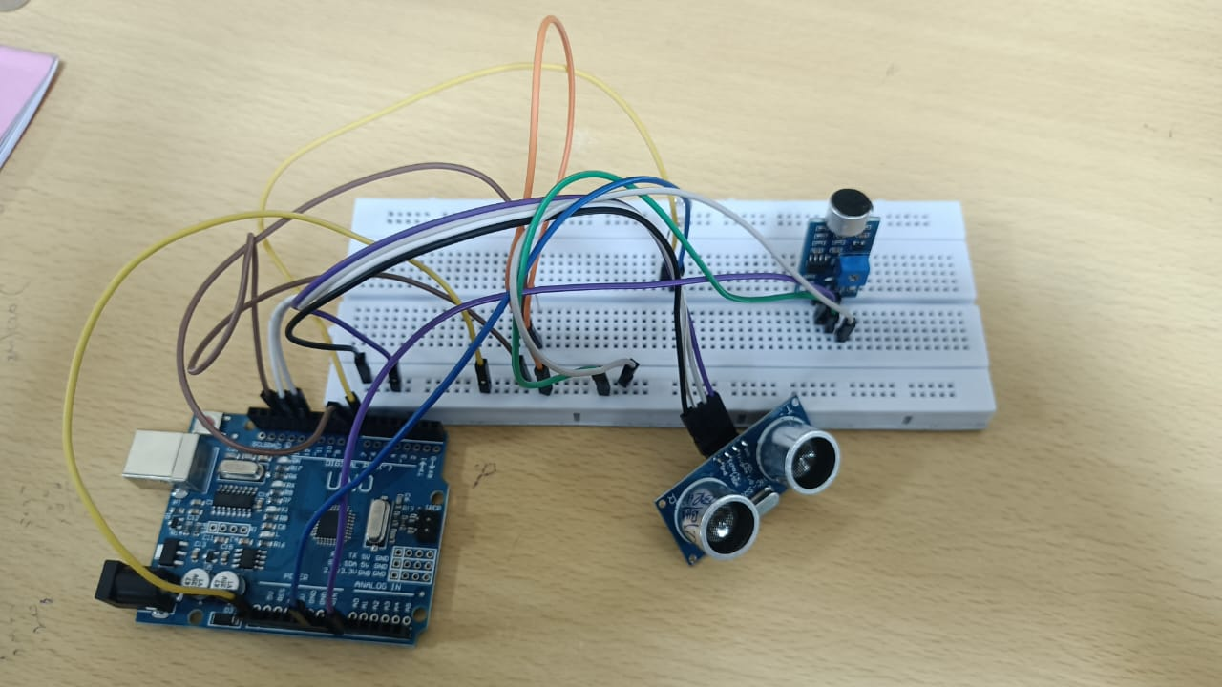

**Fig(e) Implementation using Sound and Ultrasonic sensor**

**RESULTS**

The proposed system is generally implemented using Arduino IDE Software,The aircraft detection and runway lighting system successfully provided real-time feedback on aircraft presence and sound-triggered responses. Integration of ultrasonic and sound sensors with Arduino microcontroller technology enabled accurate detection and response to aircraft activity. LED indicators promptly illuminated upon detection, enhancing situational awareness for airport personnel. The system's redundancy, ensured through serial connections for LED indicators, bolstered reliability, mitigating potential disruptions due to individual bulb failures.

**LIMITATIONS**

**Scalability Changes:**

**-** Adaptation for larger airports with multiple runways and complex layouts.

- Coordination of sensor networks and communication protocols across a vast area.

Maintenance Requirements:

- Regular calibration and maintenance of electronic components.

- Training for airport personnel in troubleshooting and repairing.

Regulatory Compliance:

- Adherence to aviation safety regulations and standards.

- Compliance with existing protocols and procedures, potentially requiring additional testing and certification processes.

**CONCLUSION**

The utilization of real-time data integration with Arduino microcontrollers represents a significant advancement in the functionality and adaptability of runway lighting systems. This innovative approach enables dynamic adjustments to lighting intensity and patterns based on various inputs, including aircraft movements, ambient light levels, and weather conditions, thereby ensuring optimal visibility for both pilots and ground personnel. Moreover, Arduino's versatility allows for seamless incorporation of additional features such as remote monitoring and control, facilitated through wireless communication protocols like Wi-Fi or Bluetooth. By harnessing the power of Arduino technology, the runway lighting system not only enhances its current capabilities but also demonstrates a readiness to embrace future advancements in aviation safety and efficiency. Through intelligent control and adaptability afforded by Arduino microcontrollers, the system effectively meets the evolving demands of modern airports and airfields, setting a precedent for innovative solutions in runway management and safety.